MING and IBCM members and friends are warmly invited to join the
special events of
St. Patrick’s Day Celebrations in Munich, 15th – 17th March,2019
Concerts – St. Patrick’s Mass – Parade
Organized by Munich Irish Network e.V. (MIN)

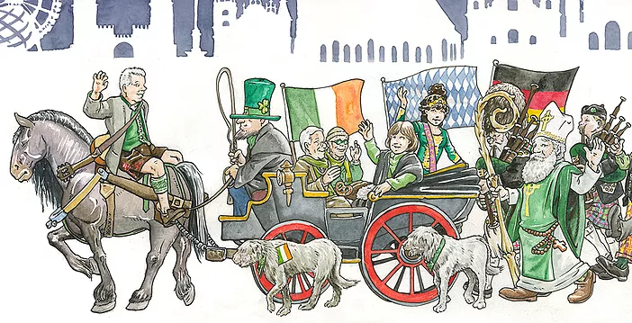
Here come the Irish! “Let’s paint the town green again” - dress in green and march with us (ca.1500 in 62 groups) to the “green fun” at the Wittelsbacherplatz. For the first time, we are celebrating a full St. Patrick’s weekend in Munich. With activities starting already on Friday, 15th March, the St. Patrick’s Weekend culminates with the Munich’s 24th St. Patrick’s Day Parade on Sunday, 17th March (1200-1330). For the parade, we will meet 1145 at Müncher Freiheit (Feillitzschstrasse, near the McDonald’s), then proceed at 1200 down the Leopoldstrasse to Odeonsplatz.
Weekend Programm:

Friday, 15th March
19:30: Hochschule für Philosophie, Kaulbachstr. 31a, 80539 München
Classical concert “Melodies of Ireland”, the classical ballads of
Thomas Moore, the „The Bard of Erin“, featuring Dean Power (Tenor),
Sinéad Campbell-Wallace (Sopran), Una Hunt (Piano).
Listen to the invitation by Dean Power
Tickets (20 €): book online at www.stpatricksday.de/melodies

Saturday, 16th March
12:00 – 18:00 Odeonsplatz: Paddy’s Food Truck Festival and Bands

18:00 St. Ludwig’s Church, Ludwigstr. 22:
St. Patrick’s Mass composed and directed by Fr. Liam Lawton

Sunday, 17th March
12:00 -13:30 from Münchner Freiheit to Odeonsplatz: The Big Parade

13:30 – 18:00 Wittelsbacher Platz:
Welcome addresses and Blessing of the Shamrock,
After Parade Party featuring “Johnny Logan & Band” and more

12:00 – 18:00 Odeonsplatz: Paddy’s Food Truck Festival and Bands

After dark St. Patrick’s Day comes to a close with the “Official Greening”:
Illumination of BMW WELT, Olympic Tower, Opera House, KENNEDY’S, KILIANS

Now let’s pray for “Kaiserwetter”

