9th Annual Bavarian-American Friendship Evening, 28th April 2019
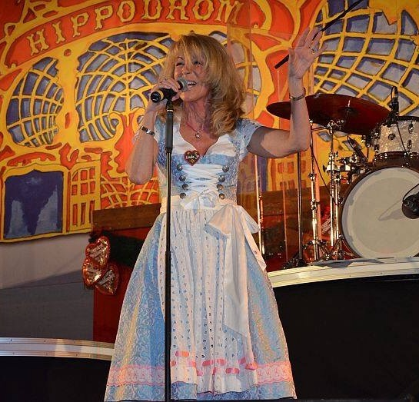
When: Sunday, 28th April, 2019
Time: 17:00-23:00
Where: Hippodrom tent located at the Frühlingsfest, Theresienwiese
Organized by: Triple D Events – Dave Dowdy
Dress code: Let’s go Bayrisch!
Price: Pay as you consume.
Again the Family Krätz, Susanne Barsody and the entire Hippodrom team welcome us to the 9th annual Bavarian-American Friendship Evening. Seating begins at 1700. Please plan to arrive by not later than 18:00 to assure that we can keep the reserved tables.
There is no cover charge and no advance payment for this evening. Each guest will receive a free pretzel, compliments of the Hippodrom. In addition to the normal assortment of Bierzelt food, we can feast on the very special Kobe-beef hamburgers.
AGBC member Linda Jo Rizzo will again lead the entertainment and will launch her special show around 8:00 p.m. Please get ready for dancing, good music and lots of fun for everyone. There is no particular dress code, but if you have some Bavarian duds in your closet, please wear them to a wonderful evening.
Last year we had around 900 guests attending. This year we can have more reserved seats, so let's join Dave to see if we can go over 1,000 this year. Please tell your friends and anyone else who may be interested. Everyone is invited, individual groups as well. To ensure that everyone gets a reserved seat, please inform Dave Dowdy at ddd@tripled.de by Wednesday, 24th April.

