180602AmericanBavarianGolfTournamentVersion2

American/Bavarian Golf Tournament – Saturday, 2nd June – SAVE THE DATE!
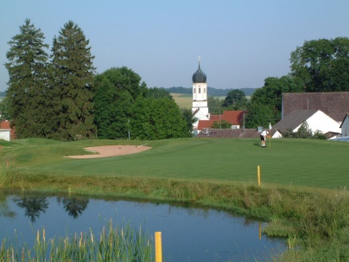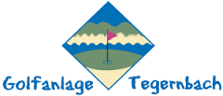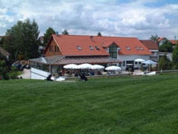

Calling all Golfers!

When: Saturday, 2nd June 2018
Time: Registration starts at 09:30 with first tee time at 10:00.
Where: Tegernbach Golf Club, Kapellenweg 1, 82293 Tegernbach, telephone 08202/905700, website www.gc-tegernbach.de,
Prices: To be announced ASAP – pricing will be quite reasonable given the Bavarian setting.
Sign-Up: Events tab on the new AGBC Munich Community Platform at www.agbc-munich.com.
Special Request: To help us estimate how many to plan for, please sign up ASAP.
Registration Deposit: Eur 50.00. This is a “first paid - first reserved” event so please be sure to sign up and pay your registration deposit by not later than Monday, 14th May 2018. Please make your payment to the AGBC Munich bank account at the Münchner Bank, Account Nr: IBAN: DE68 7019 0000 0001 0895 95, BIC GENODEF1M01.
Note: The 14th May registration date is important so that we can finalize the reservation of the golf slots, set the event day schedule, provide the caterer an idea of our food and drink needs, and determine the seating and space needs for the live entertainment.

AGBC Members Peter Barkhurst and Wolfgang Hellmanzik are organizing a great golfing day on Saturday, 2nd June at the beautiful Tegernbbach Golf Club in Tegernbach (near .Mittelstetten, about 45 km northwest of Munich).

The day will start off with two daytime golf events, essentially running in parallel:

- Golf Tournament – 18 holes which will take about 4-5 hours from the first tee. Teams will be composed of groups (flights) of 4. Course layout appears below.

- Starters Course (Schnupper Kurs) for Beginning golfers – Over 3-4 hours, the Tegernbach golf pro will help beginners learn the basics, then conduct a mini tournament on the putting green.

The action on the links will be followed by:
- A relaxing and revitalizing round of drinks at the clubhouse.
- An early evening American/Bavarian BBQ.

Calling all Sponsors!

While we already have several co-sponsors on board, if you, your company or one of your business contacts mighty be interested in also co-sponsoring this event, please contact Peter Barkhurst ASAP at p.barkhurst@aims-germany.com

Please be sure to save the date – Saturday, 2nd June - Further specifics will be communicated in the very near future.

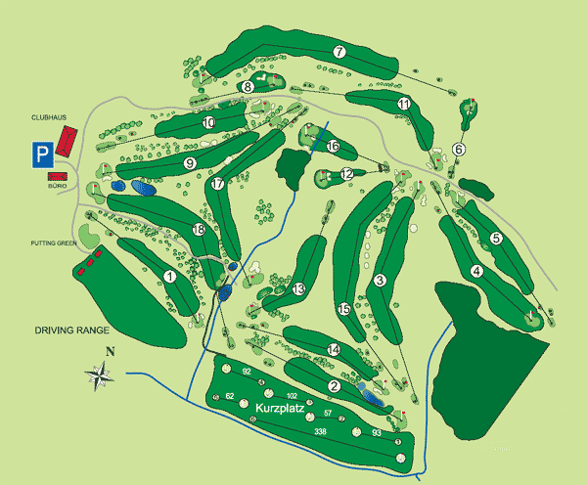

Guest information

18-hole golf course Tegernbach - A golf club membership card showing your handicap is required. VcG players are allowed.

Special Conditions:
Soft spikes required.
Dogs allowed on leash. Handy allowed on the pitch.
GPS devices allowed.

Difficulty: Moderate - Challenging

Scorecard
tea | par | CR | Slope | length
White (Men) | 73 | 72.4 | 133 | 6077 m
Yellow (Men) | 73 | 71.6 | 132 | 5931 m
Blue (Women) | 73 | 75.5 | 128 | 5498 m
Red (Women) | 73 | 72.7 | 128 | 5121 m

